URI RETO

Elaborado por

Gina Stephanie González Mateus

Universidad EAN

Base de datos

Doc. Brayan Stiven Torres

Ingeniería de Sistemas

24 de Abril de 2022

**DESARROLLO**

1. 2615 - Expanding the Business

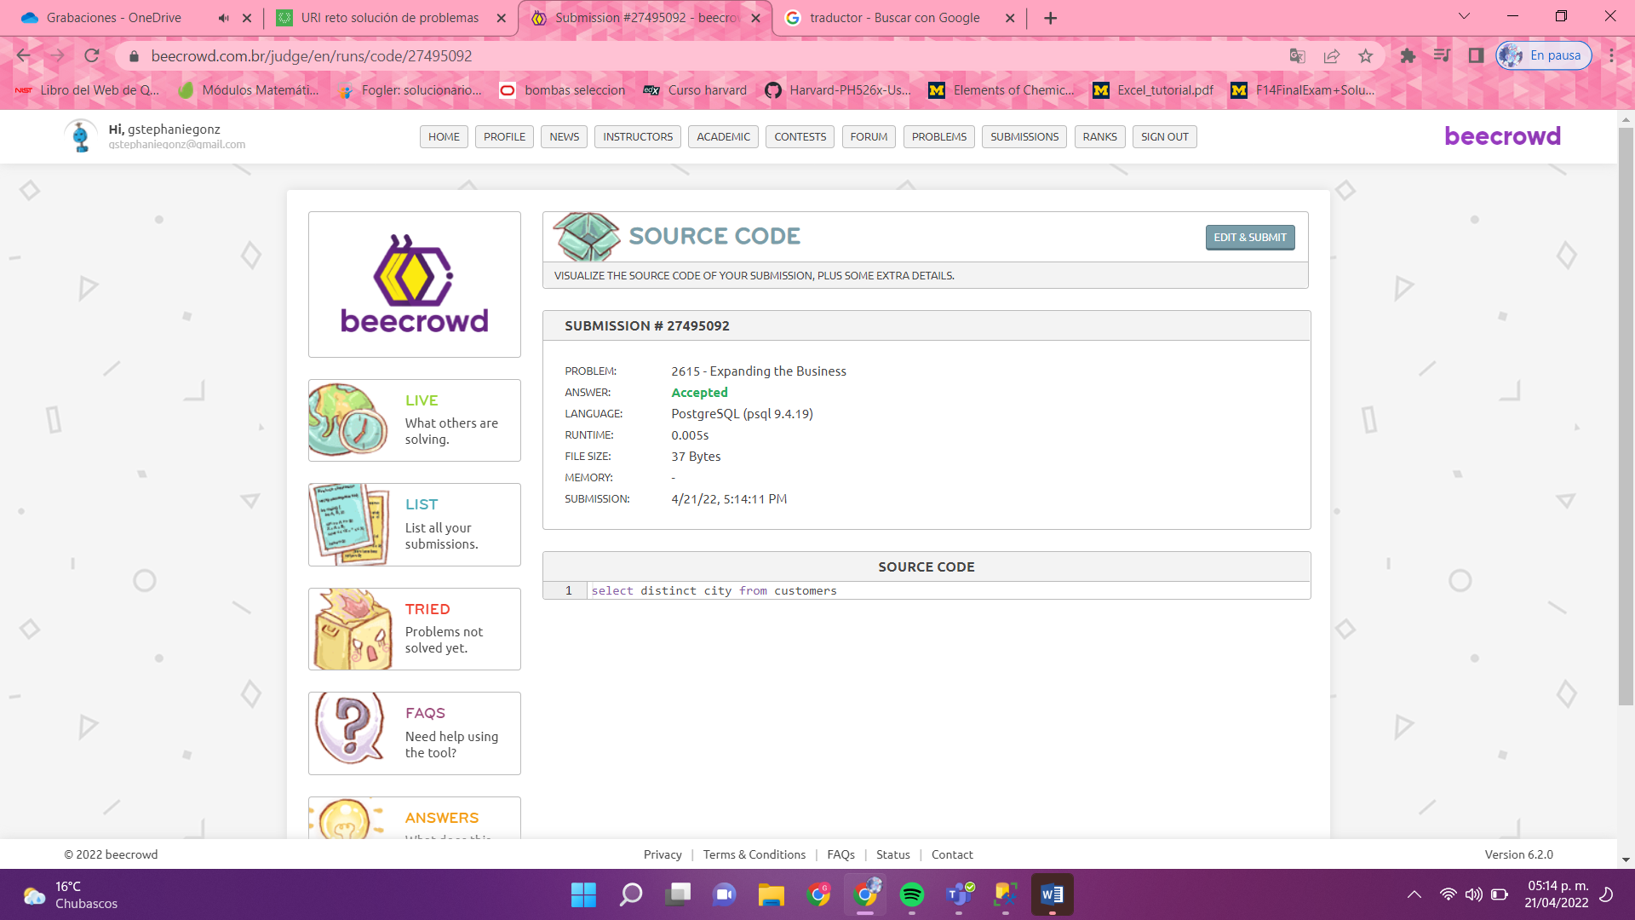

2. 2622 - Legal Person

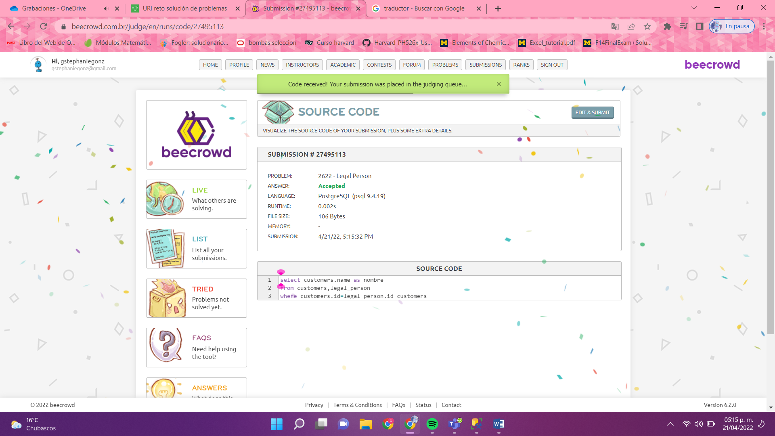

3.2611 - Action Movies

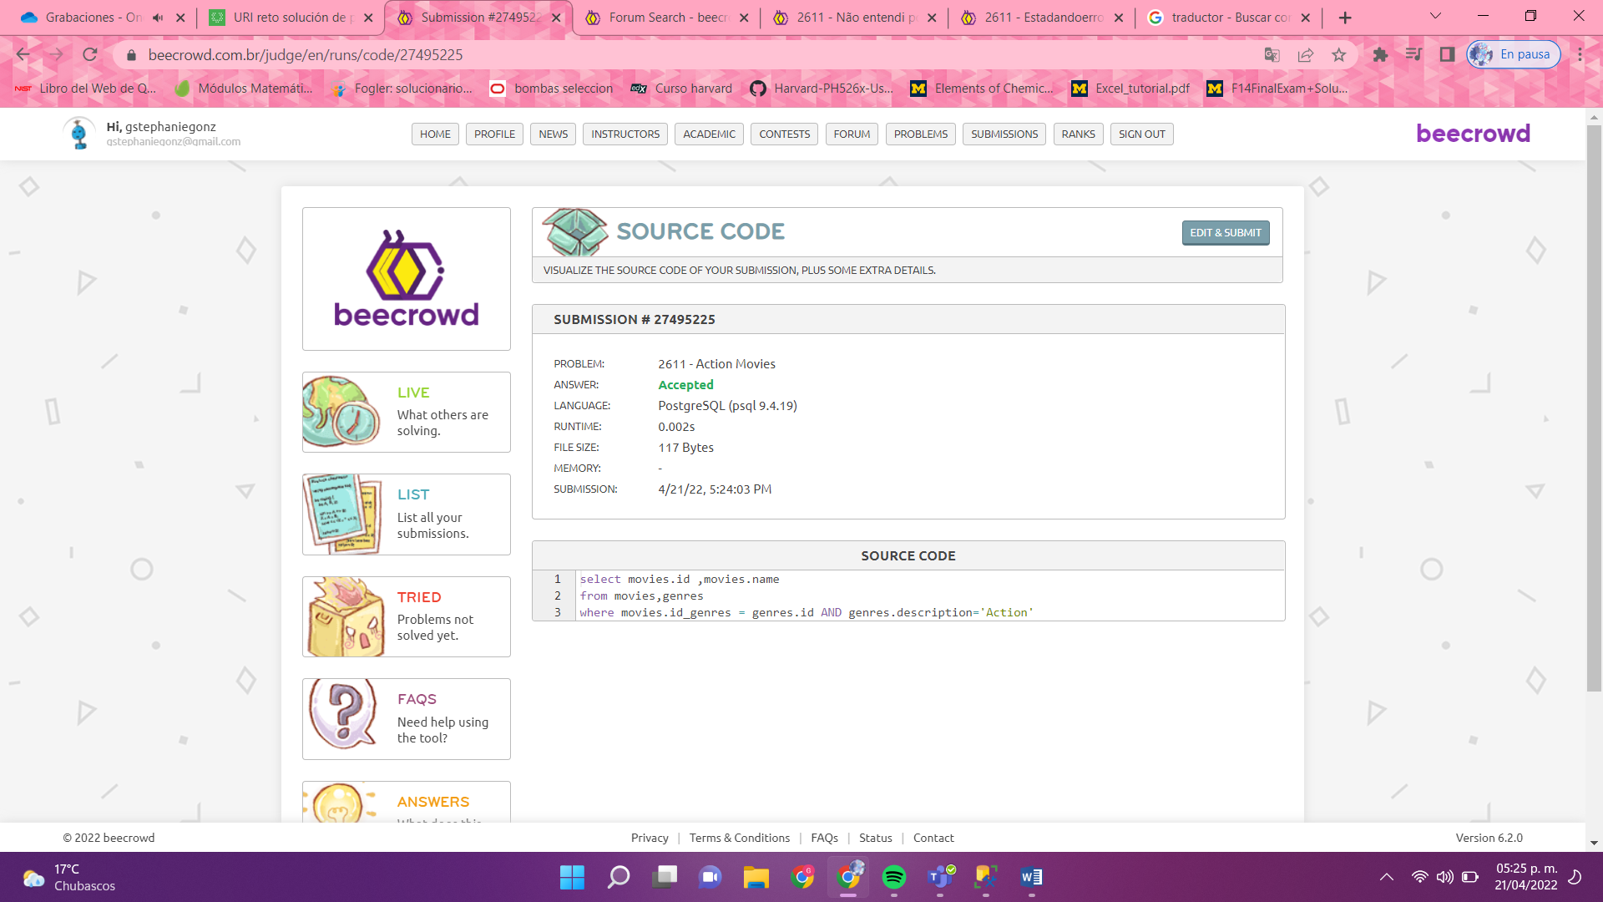

4. 2623 - Categories with Various Products

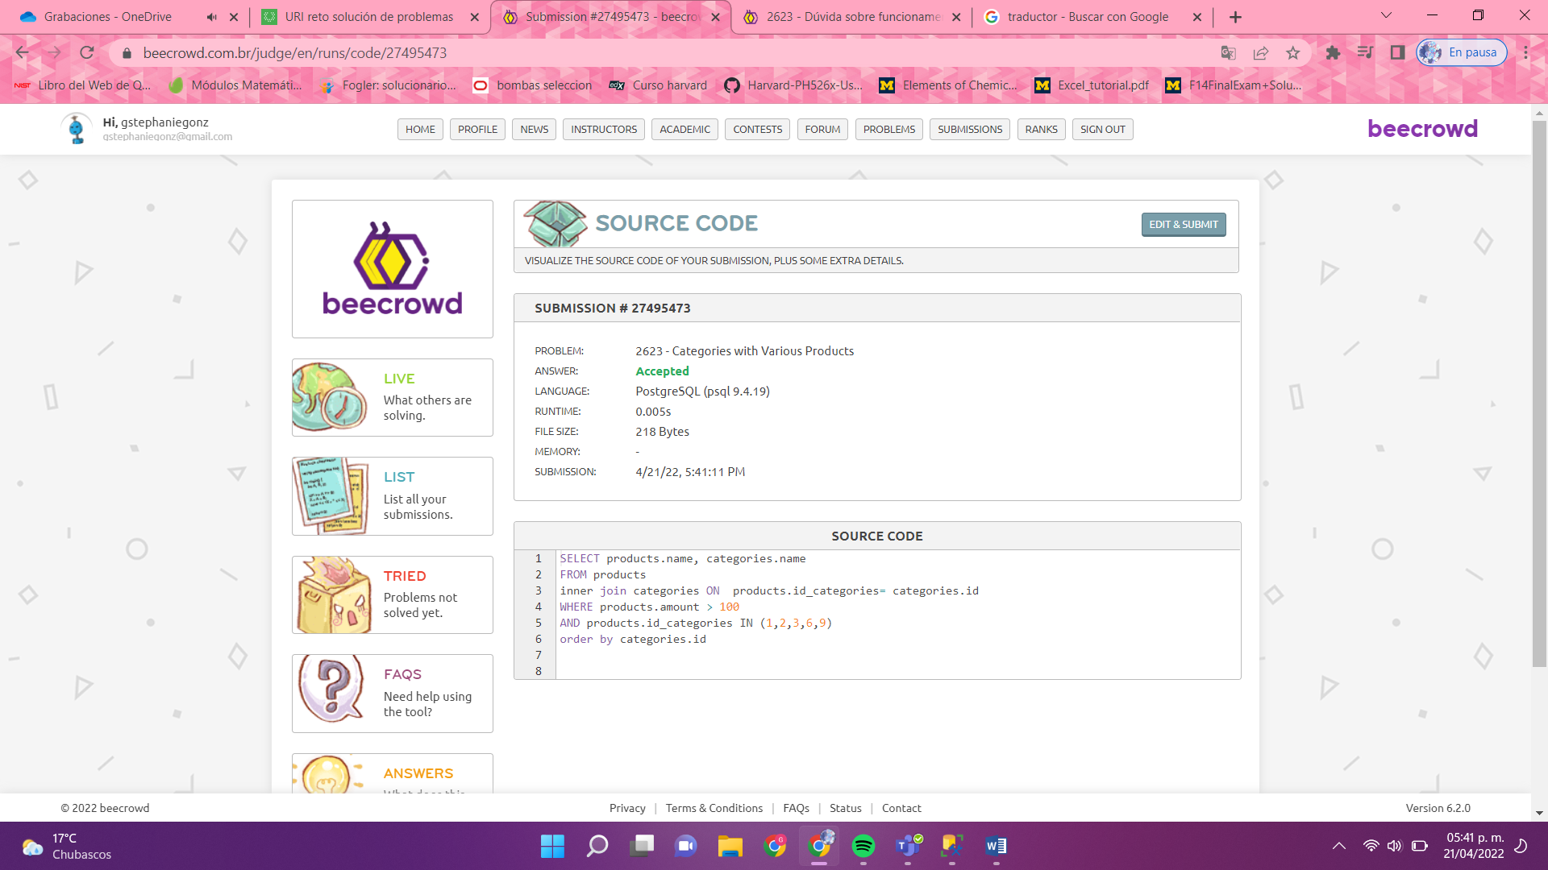

5. 2988 - Cearense Championship

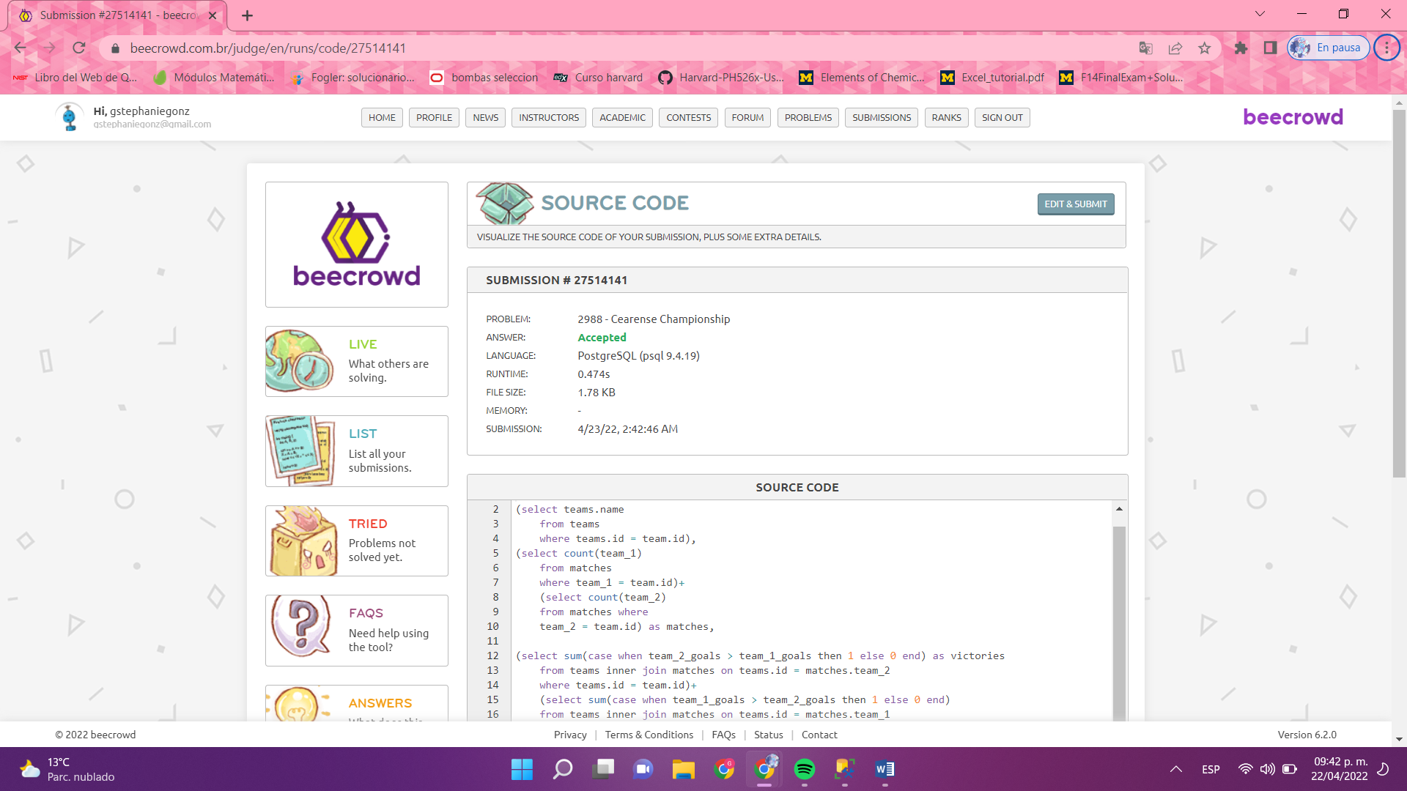

6. 2602 - Basic Select

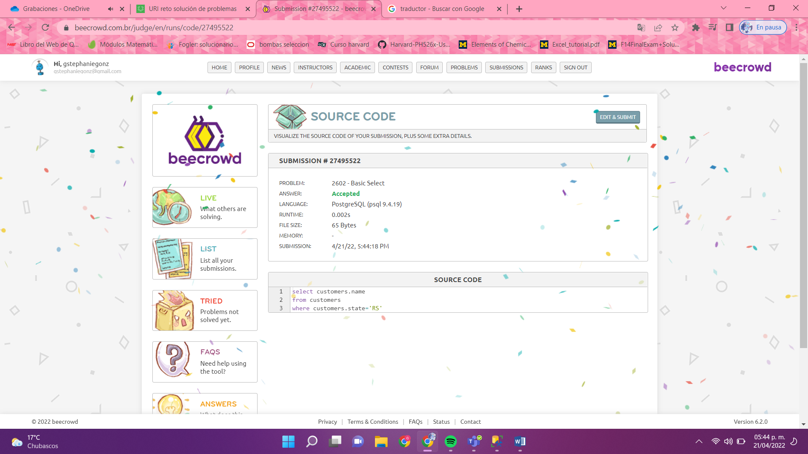

7. 2616 - No Rental

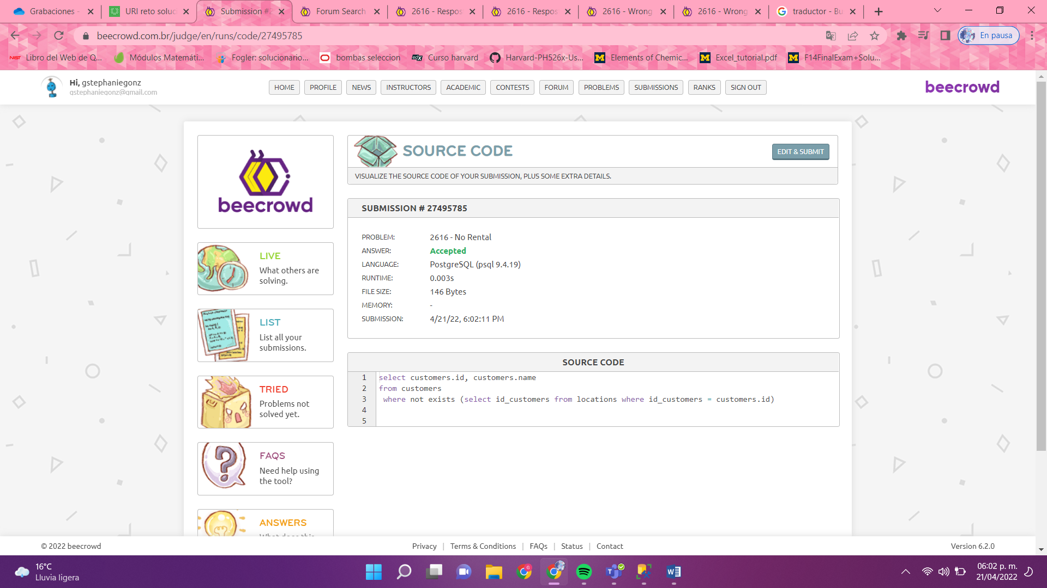

8. 2742 - Richard's Multiverse

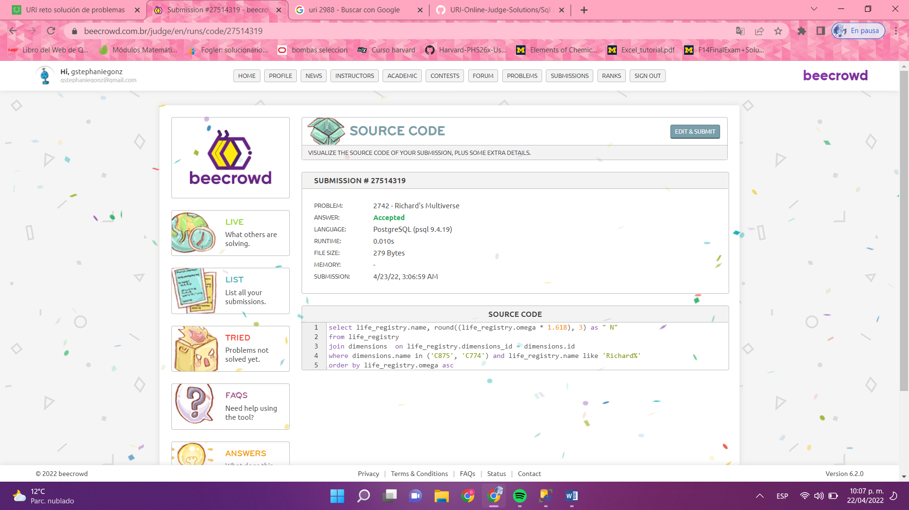

9. 3001 - Update sem Where

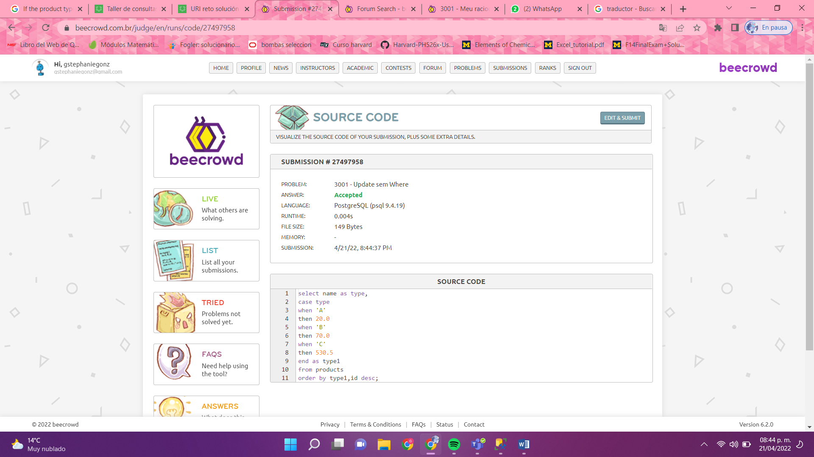

10. 2991 - Department Statistics

